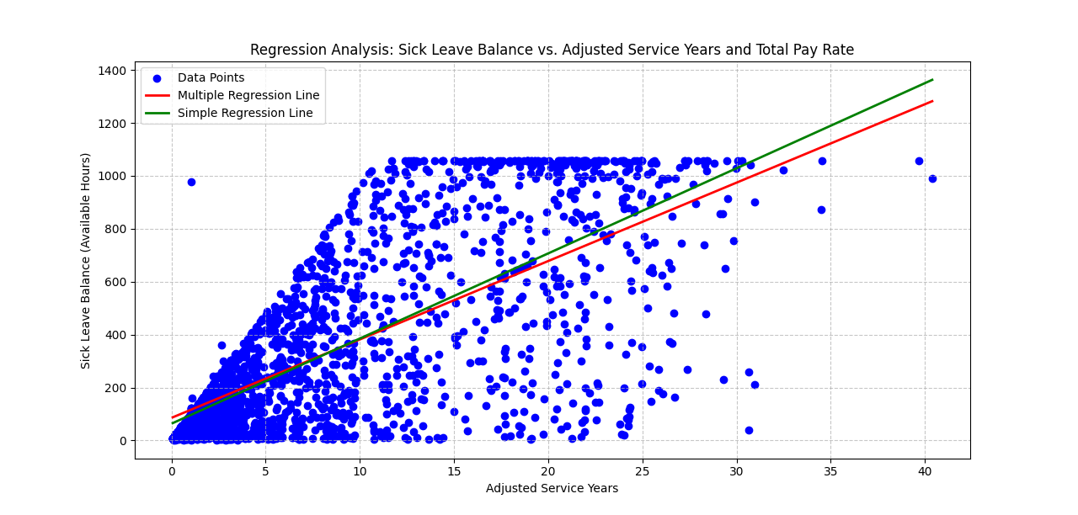Multiple Regression Analysis Results
This scatter plot visualizes the relationship between Sick Leave Balance (Available Hours) and Adjusted Service Years.
Key Points
- Data Points: Each blue dot represents an individual employee’s Sick Leave Balance and Adjusted Service Years.

- Multiple Regression Line: The red line represents the best-fit multiple regression line that models the relationship between Sick Leave Balance and Adjusted Service Years, considering Total Pay Rate.

- Simple Regression Line: The green line represents the best-fit simple regression line that models the relationship between Sick Leave Balance and Adjusted Service Years alone.

Regression Analysis Results

1. **Coefficients**:
- In the simple regression model, the coefficient for Adjusted Service Years is approximately 32.17, indicating that for each additional year of service, the Sick Leave Balance increases by about 32.17 hours.

- In the multiple regression model, the coefficient for Adjusted Service Years is slightly lower at approximately 29.63, suggesting that when accounting for Total Pay Rate, the impact of service years on Sick Leave Balance is slightly reduced.
- The coefficient for Total Pay Rate in the multiple regression model is approximately 3.20, indicating that higher pay rates are associated with higher Sick Leave Balances.
2. **R-squared**:
- The R-squared value for the simple regression model is approximately 0.539, meaning that about 53.9% of the variability in Sick Leave Balance can be explained by Adjusted Service Years alone.

- The R-squared value for the multiple regression model is higher at approximately 0.570, indicating that including Total Pay Rate as an additional predictor improves the model's explanatory power to about 57%.
3. **p-values**:
- The p-values for both models are extremely small, indicating that the predictors are statistically significant in explaining the variability in Sick Leave Balance.

Conclusion
The multiple regression analysis provides a more comprehensive understanding of the factors influencing Sick Leave Balance by considering both Adjusted Service Years and Total Pay Rate. The inclusion of Total Pay Rate as a predictor enhances the model's explanatory power, highlighting its importance in understanding employee behavior related to sick leave.

